**Lesson1 ESP8266 Introduction:**

The ESP8266 NodeMCU is a low-cost, easy-to-use Wi-Fi module that is widely used in IoT applications. It is based on the ESP8266 Wi-Fi chip, which has a 32-bit CPU and a built-in Wi-Fi module, allowing it to connect to Wi-Fi networks and interact with other devices on the Internet. The NodeMCU board is designed to make it easy to program and use the ESP8266, and it can be programmed using the Arduino IDE, Lua or MicroPython.

**Parts of ESP8266 NodeMCU**:

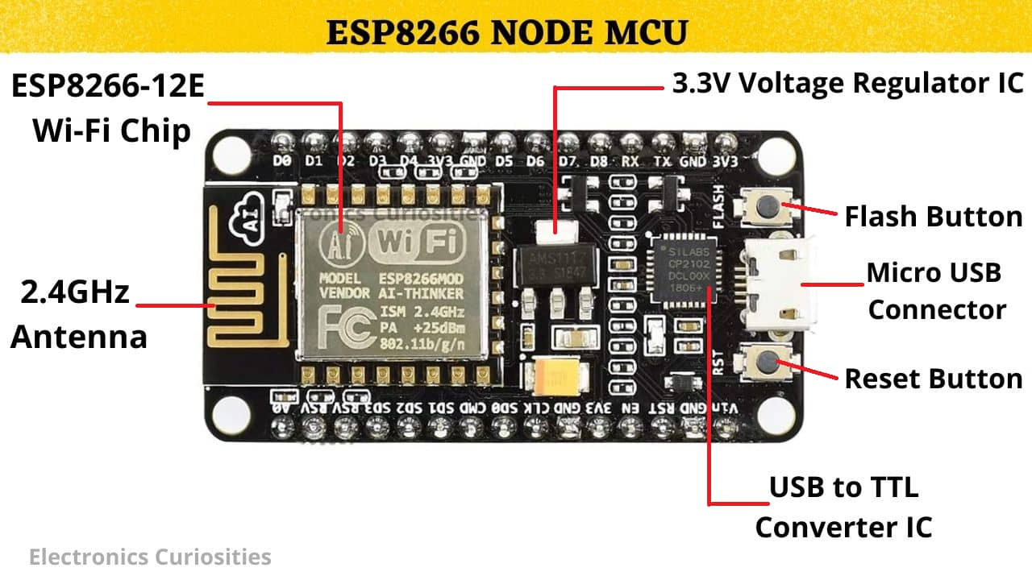

**ESP8266 Wi-Fi chip**: This is the heart of the NodeMCU, which has a 32-bit CPU and a built-in Wi-Fi module that supports IEEE 802.11 b/g/n Wi-Fi standards. It can be programmed to connect to Wi-Fi networks and interact with other devices on the Internet.

Flash Memory: 4 MB

SRAM: 64 KB

Clock Speed: 80 MHz

Power pins (3.3 V).

Ground pins (GND).

Analog pins (A0).

Digital pins (D0 – D8, SD2, SD3, RX, and TX – GPIO XX)

Pin Code Arduino alias

A0 A0 A0

D0 GPIO 16 16

D1 GPIO 5 5

D2 GPIO 4 4

D3 GPIO 0 0

D4 GPIO 2 2

D5 GPIO 14 14

D6 GPIO 12 12

D7 GPIO 13 13

D8 GPIO 15 15

SD2 GPIO 9 9

SD3 GPIO 10 10

RX GPIO 3 3

TX GPIO 1 1

**USB to UART Bridge**: The NodeMCU board has a USB to UART bridge, which is used to connect the board to a computer for programming and debugging. It allows you to communicate with the ESP8266 chip using a serial interface.

**Power regulator**: The NodeMCU board has a power regulator that can accept input voltages between 5V to 12V and provide a stable 3.3V output for the ESP8266 chip and other components on the board.

**GPIO pins**: The NodeMCU board has several General Purpose Input/output (GPIO) pins that can be used to interface with external components, such as sensors, relays, LEDs, and other devices. These pins can be controlled by the ESP8266 chip using software.

**Analog Input pins**: The NodeMCU board has one analog input pin (A0) that can be used to measure analog voltages from 0 to 3.3V. It can be used to connect sensors that output analog signals, such as light sensors, temperature sensors, and potentiometers.

**Reset and Flash buttons**: The NodeMCU board has a reset button that can be used to reset the ESP8266 chip and a flash button that can be used to put the chip into programming mode.

**LED indicators**: The NodeMCU board has several LED indicators that can be used to indicate the status of the board, such as power, Wi-Fi connection status, and data transmission activity.

In summary, the ESP8266 NodeMCU is a versatile and powerful Wi-Fi module that is widely used in IoT applications. It has a variety of features and components that can be used to interface with external devices, and it can be programmed using various programming languages, making it easy to use for both beginners and advanced users.

**Safety** **Considerations**

When working with the ESP8266 NodeMCU board, there are several safety considerations to keep in mind to ensure both personal safety and the longevity of the board itself:

Power supply: The board should be powered using a power supply that meets the specifications of the board. Using an incorrect power supply can damage the board and create a safety hazard.

ESD Protection: The board and other electronic components should be protected from electrostatic discharge (ESD) by working on an ESD-safe work surface and wearing an ESD wrist strap. ESD can damage the board or other electronic components.

Soldering: If soldering is required to connect components to the board, use appropriate safety equipment such as safety goggles and a soldering iron stand to prevent burns and injuries.

Component polarity: Make sure to properly identify the polarity of components such as diodes and capacitors before installing them on the board. Incorrect polarity can cause damage to the component or the board itself.

Pinout: It is important to carefully check the pinout of the board and components to avoid damage due to incorrect connections. Double-checking connections can help to prevent short circuits and other electrical hazards.

Operating conditions: Be aware of the operating conditions of the board and ensure that it is operated within its specified operating range. This can help to prevent overheating, which can damage the board or create a safety hazard.

By following these safety considerations, you can work with the ESP8266 NodeMCU board safely and ensure that it remains in good working condition for longer.

VIN

The ESP8266 NodeMCU board does have a VIN pin, which is a power input pin. The VIN pin allows you to supply power to the board using an external power source, such as a battery or an AC-to-DC adapter.

The VIN pin is connected to the power regulator on the board, which regulates the input voltage to 3.3 volts, which is the voltage required by the ESP8266 chip. It is important to note that the input voltage should be between 4.5V and 9V DC. If you apply voltage outside of this range, it could damage the board.

The VIN pin is an optional power input. The board can also be powered through the USB port using a USB cable connected to a computer or other USB power source.

When using the VIN pin, it is important to ensure that the external power source can provide sufficient current for the board and any connected components. The amount of current required will depend on the specific application and components being used. You should check the specifications of the components being used to determine the current requirements, and select an appropriate power supply that can meet those requirements.

**Tips: for Multiple Switch Relay users**

When using multiple output pins on the ESP8266 NodeMCU board to control multiple switch relays, it is important to be aware of the current draw and power requirements of the relays. If the combined current draw of all the relays is too high, it can overload the output pins on the board and potentially damage it.

To mitigate the excessive load on the ESP8266 NodeMCU board, there are a few options:

Use a relay module: A relay module is a separate board that includes one or more relays and can be controlled by the ESP8266 NodeMCU board using a single output pin. The relay module has its own power supply, which means that the load is not placed on the ESP8266 NodeMCU board. This is a safer and more reliable option, especially when controlling multiple relays.

Use an external power supply: If you are not using a relay module, you can use an external power supply to power the relays. This takes the load off the ESP8266 NodeMCU board and reduces the risk of overloading the output pins.

Limit the number of relays: If you must control multiple relays directly from the ESP8266 NodeMCU board, you can limit the number of relays being controlled simultaneously to reduce the load on the output pins. You can also use transistors or driver circuits to increase the current capacity of the output pins.

Use a power transistor: You can use a power transistor to switch the power supply for the relay instead of directly switching the current from the ESP8266 output pins. This way, the current will not flow through the ESP8266 output pins, which can avoid the excessive load on the board.

By taking these precautions, you can use the ESP8266 NodeMCU board to control multiple switch relays safely and effectively without overloading the board or damaging it.